Project Design Phase-II
Technology Stack (Architecture & Stack)

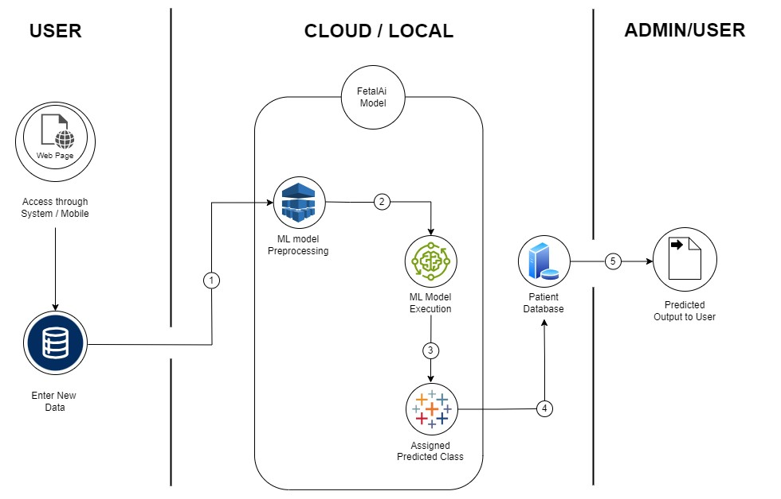
Technical Architecture:

Table-1: Components & Technologies:

S.No | Component | Description | Technology
1. | User Interface | User Interacts with webpage UI through system or mobile device | HTML, CSS, JavaScript
2. | User Explorers the FetalAI Webpage | Explore pages (about us, contact us, Analyse, Home  page) | HTML, CSS, JavaScript
3. | User fill the Analyse form to do prediction | Fill new data for prediction | HTML form
4. | Machine Learning Model | ML model used for prediction fetal health | Random  Forest
5. | Database | Predicted value is saved into patient’s database | MySQL
6. | Infrastructure | Application deployment on local system | Local

Table-2: Application Characteristics:

S.No | Characteristics | Description | Technology
1. | Open-source Frameworks | Bootstrap, Python Library | Python, HTML, CSS, JavaScript
2. | Availability | Very low load on the webpage | Simple HTML Page
3. | Performance | Responsive webpage to work on mobile and laptop seamlessly | Responsive CSS coding
4. | Scalable Architecture | Number of input field can be increased by altering ML model | ML Modelling

